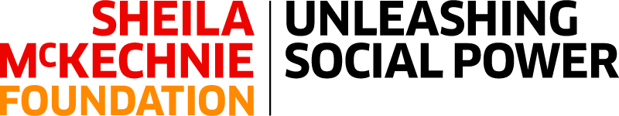

Trustee Role Description

The Sheila McKechnie Foundation (SMK) is here for people working to make lasting change, whether in their community, across society, or for our planet.

We support change-makers by sharing the latest thinking and advice. We connect the campaign community to grow solidarity, share ideas, and find common cause. And we act as a powerful champion for the right to campaign.

Our Board of Trustees is responsible for the overall governance and strategic direction of SMK providing inclusive leadership in pursuit of our aims, objectives and goals in accordance with our governing document, legal and regulatory guidelines.

Key Responsibilities:

1. Supporting the governance and strategic development of SMK as an organisation

2. Providing strategic advice and practical assistance where required to ensure that SMK delivers on its core aims and areas of work:

3. Providing effective governance and furthering the organisation in keeping with its charitable objectives

4. Maintaining sound financial management and oversight of SMK resources and ensuring the organisation meets its financial obligations when they are due and accounts for all its financial dealings

5. Ensuring the organisation meets its obligations as a registered charity and a company limited by guarantee

6. Acting in the best interests of SMK at all times upholding the charities’ values in accordance with the trustee Code of Conduct and SMK’s Solidarity & EDI commitments.

Reporting to: Chair and Vice-Chair of the Board

Time commitment:

The Board meets a minimum of four times per year for core business, with one additional board and staff strategic planning day held in the summer.

Some trustees additionally sit on the Resources Group which also meets four times a year, though for a shorter meeting and always on-line.

Trustees may also be requested to commit time to work on specific projects with the executive, and attend other ad hoc meetings and events representing SMK in engagements with key stakeholders.

We expect trustees to spend an average of 1 – 1.5 days a month on SMK business.
Training

Training can be provided following induction. There is an option to request further development support subject to the organisation’s budget.

The Board assesses its own performance annually, and monitors its diversity, skills and experience profile as part of SMK’s wider commitment to Solidarity & EDI.

Remuneration:

The role of trustee is voluntary and not accompanied by any financial remuneration, although reasonable expenses for travel may be claimed.

